SPARK UK (Devon) CIC – Safeguarding and Child Protection Policy

Policy Reviewed: | March 2024
Review Date: | March 2025 (unless required before)

Key Personnel:
Nominated Child Protection Lead | Caroline Pinsent | caroline@sparkuk.co.uk
Deputy Nominated Child Protection Lead | Bridie Downing | bridie@sparkuk.co.uk

Safeguarding Statement:
Spark UK (Devon) CIC predominantly endeavour to spark a conversation around Mental Health in children and young people. Spark UK do not work directly with children and young people unless the children and young people are accompanied and supervised by education staff.

We recognise that all children, regardless of age, disability, SEND, gender reassignment, race, religion or belief, sex, or sexual orientation have an equal right to protection from all types of harm or abuse. We are alert to the signs of abuse and neglect and follow our procedures to ensure that children receive effective support, protection, and justice. When there are concerns for a child’s welfare, we may need to share information and work in partnership with other agencies. We will ensure concerns are discussed with parents/carers first unless we have reason to believe that doing so would be contrary to the child’s welfare. This Child Protection and Safeguarding policy underpins and guides our safeguarding procedures and protocols.

The purpose of this policy statement is:
- To protect children and young people who access support through Spark UK’s services from harm.
- To safeguard and promote the welfare of all children who access services by Spark UK.

This policy applies to anyone working on behalf of Spark UK (Devon) CIC including senior management, advisors, trustees and volunteers.

We are committed to reviewing our policy and good practice annually. Earlier reviews will be undertaken if there is a significant change in legislation, change in organisation roles and responsibility or when learning has taken place through experience.

Legal Framework:
This policy has been drawn up on the basis of legislation, policy and guidance that seeks to protect children in England. This legislation, guidance and policy includes:

- Children’s Act 1989
- Keeping children safe in education - GOV.UK (www.gov.uk)
- Working together to safeguard children - GOV.UK (www.gov.uk)
- Safeguarding for charities and trustees - GOV.UK (www.gov.uk)
- United Convention of the Rights of the Child 1991
- Data Protection Act 2018
- Human Rights Act 1998
- Children & Families Act 2014
- Safeguarding Vulnerable Groups Act 2006
We recognise that:
- The welfare of a child is paramount, as established in The Children Act 1989 and the United Convention of the Rights of the Child 1991.
- All children, regardless of age, disability, gender reassignment, race, religion or belief, sex, sexual orientation (as detailed in the Equality Act 2010), have a right to equal protection from all types of harm or abuse.
- Some children are additionally vulnerable because of the impact of discrimination, previous experiences, their level of dependency, communication needs or other issues.
- Working in partnership with children and young people, their parents/carers, and other agencies is essential in promoting young peoples’ welfare.

Forms of harm or abuse
To safeguard others, it is vital to understand the forms of harm and abuse and the signs that an individual is being subject to abuse.

Working Together to Safeguard Children 2023 defines abuse as:
‘A form of maltreatment of a child. Somebody may abuse or neglect a child by inflicting harm, or by failing to act to prevent harm. Children may be abused in a family or in an institutional or community setting by those known to them or, more rarely, by others. Abuse can take place wholly online, or technology may be used to facilitate offline abuse. Children may be abused by an adult or adults, or another child or children.’

There are four major types of abuse:
- Physical Abuse
- Emotional Abuse
- Sexual Abuse
- Neglect

There are other types of abuse that fit into these categories. These include but are not restricted to: Child Sexual Exploitation (CSE), Female Genital Mutilation (FGM), radicalisation, coercive control, domestic abuse, and bullying.

Policy Principles, Aims and Values:
The Nominated Child Protection Lead (Caroline Pinsent) take lead responsibility for safeguarding and child protection for Spark UK (Devon) CIC.
This responsibility includes:
- Robust and regular safeguarding training for all directors, volunteers, advisors and trustees who work for Spark UK.
- Clear referral pathways for Spark UK to raise concerns of possible child abuse and neglect including when appropriate to children’s social care and / or police.
- Robust safer recruitment processes to ensure any suitable people work for Spark UK.
- Robust Whistleblowing processes to ensure all directors, volunteers and trustees know how to raises concerns regarding colleagues in required.

In the absence of the Nominated Child Protection Lead (Caroline Pinsent) the Deputy Nominated Child Protection Lead with act as Nominated Safeguarding Lead for Spark UK.

Both the Nominated Child Protection Lead and the Deputy will be trained to Level 3 in Safeguarding and Child Protection.

If anyone representing Spark UK has safeguarding concerns for a child or young person and believes they may be at risk of harm they will follow the following process:

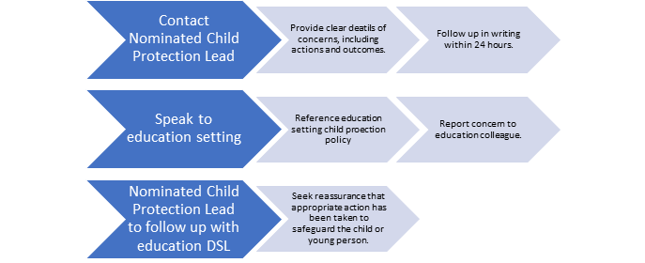

If appropriate and Spark UK feels there is evidence that the child is at significant risk or harm, they will contact the Local Authority Children Services team (LA address of the Child) and the police if the risk is urgent.

Spark UK will not hold any information regarding children and young people. If there are safeguarding concerns for a child or young person and a representative from Spark UK reports this to the Nominated Child Protection Lead this information will be saved securely (using a password-protected document) and as soon as Spark UK has sought assurance that the education provider has taken appropriate action this information will be deleted.

All Spark UK directors, volunteers and trustees will undertake regular safeguarding training, this will include reading key documentation Keeping Children Safe in Education (Part One and Annex B) and all training will be in line with requirements in KCSiE.
This training will be evidenced, and this information will be held by the Nominated Child Protection Lead.

If a child, young person or vulnerable adult contacts Spark UK directly via email or social media where possible the process shown above will be followed. If the person contacting Spark UK is anonymous and has not provided contact details the Nominated Child Protection Lead will take reasonable steps to identify the person and report to the appropriate professionals whenever possible (Police, Children’s Social Care or Adult social care).

A significant element of the work undertaken by Spark UK (Devon) CIC is advising education settings on how to support their pupils with their mental health, providing resources and speaking at events regarding the importance of talking about mental health. To ensure up-to-date, relevant, and correct information is being shared by Spark UK we have a board of advisors who have a wide range of knowledge, skills and experiences and sign off on all advice and resources before them being released for use.

Whistleblowing:
All directors, volunteers and trustees that represent Spark UK are trained to recognise Whistleblowing concerns including low-level concerns.

If anyone representing Spark UK has Whistleblowing concerns, they must follow the following process:

If the concern is regarding an education colleague:

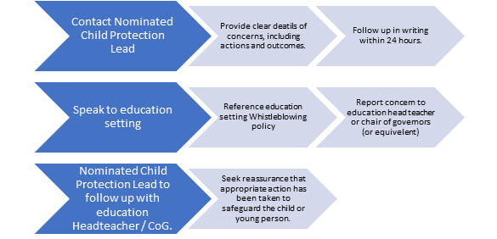

If appropriate and Spark UK feels there is evidence that the child is at significant risk or harm, they will contact the Local Authority Designated Officer (LA address of the Child) and the police if the risk is urgent.

If the concern is regarding a Spark UK representative:

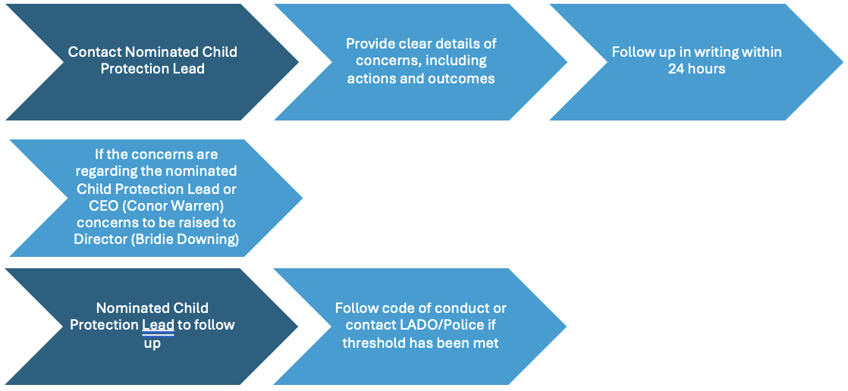

If appropriate and Spark UK feels there is evidence that the child is at significant risk or harm, they will contact the Local Authority Designated Officer (LA address of the Child) and the police if the risk is urgent.

All Whistleblowing concerns regarding directors, volunteers and trustees for Spark UK will be logged by the directors in password-protected files. These files will only be accessible to the directors.

